**Abstract landscape background with crane birds**

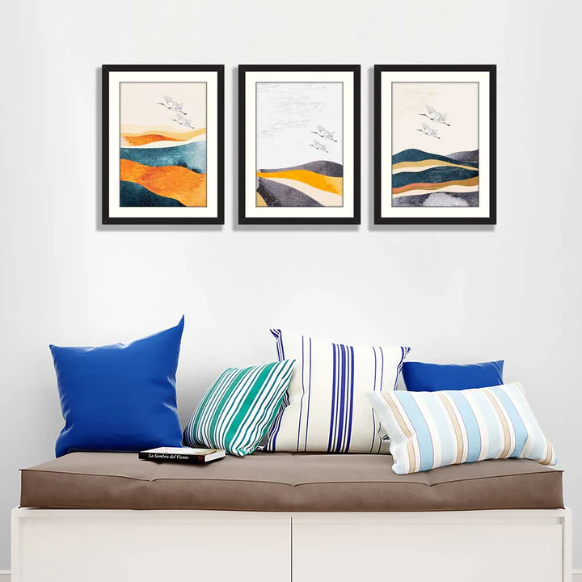An abstract landscape background featuring crane birds offers a serene and evocative scene, where the natural beauty of the environment meets the elegance of these graceful birds. The landscape itself can be a blend of soft, flowing colors—muted blues, gentle greens, and warm earth tones—that create an impressionistic view of distant mountains, flowing water, or open fields. The cranes, often depicted in mid-flight or gracefully perched, add a dynamic contrast to the stillness of the background. Their slender bodies and long, delicate wings become focal points within the abstract scenery, symbolizing freedom, peace, and harmony with nature. The combination of abstract forms and the symbolic presence of cranes creates a tranquil yet powerful visual narrative, perfect for evoking a sense of calm, beauty, and connection with the natural world. This type of artwork is ideal for modern interiors, blending the fluidity of abstract expression with the timeless elegance of nature.